// TODO add title page image

|  |  |
| --- | --- |
|  | **Level Design   Document** |
|  | UFCF7M-30-2 Game Level Design |
|  | *William Whitehouse 19019239* |

Contents

Change Log 3

Copyright Notice 3

Overview 4

Quick Summary / X-Statement 4

Game Concept 4

Objective Summary 6

Location 6

Metrics 6

Level Atmosphere & Mood 6

High-Level Design Devices 7

Player Activities & Actions 7

Equation 7

Level Rules (Sieve) 8

Level Design 9

Level Flow Diagram 9

Level Bubble Diagram 9

Detailed Level Bubble Diagram 10

Maps 11

Island Map 11

Platforming & Puzzle Maps 12

Elevations 14

Game Design 15

Lighting 15

Physics 15

Particles 15

Logic 16

Interaction 16

Torches 16

Push Blocks 16

The Other Side Portal 16

Objective System 16

First Ability: Double Jump 16

Second Ability: Shooting Dark Energy 16

Weather System 17

User Interface (UI) 17

Heads Up Display (HUD) 17

Audio & Sounds Effects 18

Weather System 18

Stone Door Opening 18

Entering the Portal 18

Monster Sound Effect 18

Cinematics 18

Opening Cinematic 18

Ending Cinematic 18

Win Cinematic 18

Lose Cinematic 18

Entities 19

Villager 19

Monster 19

Key 20

Crowbar 20

# Change Log

|  |  |  |
| --- | --- | --- |
| Version No. | Date | Significant Changes |
| 3.2 | 17/01/2021 | Updated cover page copyright notice |
| 3.1 | 16/01/2021 | Added images to entities |
| 3.0 | 13/01/2021 | Added items to entities |
| 2.9 | 12/01/2021 | Updated particle effects in game design |
| 2.8 | 04/01/2021 | Added weather system to logic |
| 2.7 | 04/01/2021 | Updated level maps |
| 2.6 | 02/01/2021 | Rewritten Game Concept |
| 2.5 | 30/12/2020 | Added cinematics and entities section |
| 2.4 | 21/12/2020 | Redesigned [UI](#_User_Interface_(UI)) section of game design |
| 2.3 | 19/12/2020 | Added audio and sound effects |
| 2.2 | 18/12/2020 | Amended Physics section of game design |
| 2.1 | 17/12/2020 | Added Logic section to game design |
| 2.0 | 16/12/2020 | Amended Level flow diagram |
| 1.9 | 16/12/2020 | Added [level rules](#_Level_Rules_(Sieve)) |
| 1.8 | 14/12/2020 | Amended Game Design section |
| 1.7 | 14/12/2020 | Added Game Design section |
| 1.6 | 12/12/2020 | Added puzzle and platforming maps |
| 1.5 | 09/12/2020 | Added level maps |
| 1.4 | 08 /12/2020 | Added Bubble Diagrams and detailed bubble diagram |
| 1.3 | 05/12/2020 | Added Equation and Copyright Notice. Reformatted Onion Diagram |
| 1.2 | 05/12/2020 | Rewritten Game Concept, fixed and replaced Onion Diagram and fixed Objective Summary to match new game concept. |
| 1.1 | 02/12/2020 | Added introduction paragraph to Level Flow Diagram. |
| 1.0 | 01/12/2020 | Initial document creation |

# Copyright Notice

This document and its contents are copyright of William Whitehouse - All rights reserved.

Any redistribution or reproduction of part of or all the contents in any form is prohibited other than the following:

* You may print, download, or store a local copy for your personal and non-commercial use only.
* You may copy the contents to individual third parties for their personal use, but only if you acknowledge the document as the source of the material

# Overview

## Quick Summary / X-Statement

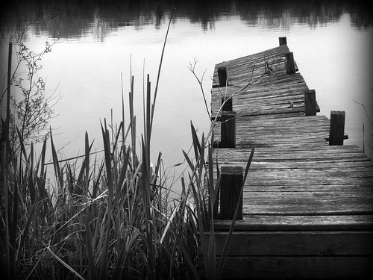

Figure 1 - Old Ruined Docks

The player must find missing persons but gets trapped in another realm. Then the player must escape the island before being captured by the monster who dwells there.

## Game Concept

A mainland police office, the player, arrives on a damp and dull isolated Scottish island by boat. They dock the boat at a small, very poorly maintained dock, they are only one other boat docked there. The mainland police officer is there to investigate disappearances, they are directed to the old police station to get up to speed on the current investigation. The player gets some information about the disappearances and uncovers that they have some connection to a cabin. This cabin is on the highest hill on the island.

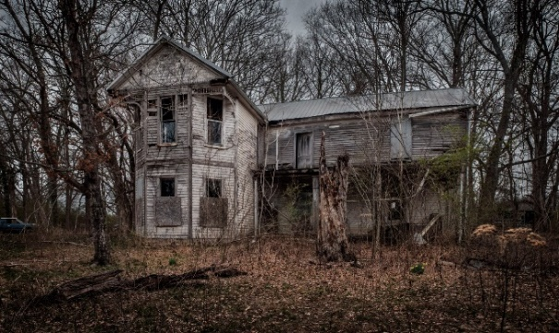

Figure 2 - Cabin in the woods

The Player heads towards the hill following dim torchlight to explore, once they have reached the top, they see an old cabin and an old lighthouse. The cabin is locked. The player must open this door to progress, they can either use a key that is hidden at the top of the lighthouse or a crowbar that can be found somewhere in the village. The player can look through the cabin windows to see inside they can see a hole heading into the ground in the far corner of the cabin with a faint light emanating from it. Once the player enters the cabin, they fall down the hole and enter the cave system below. There is no way back up, but they learn the double jump ability.

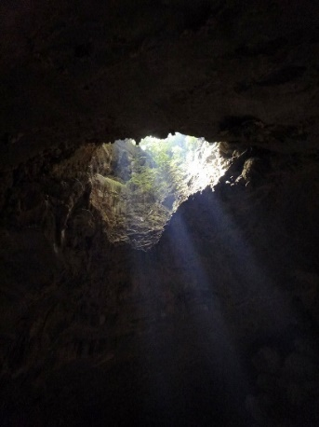

Figure 3 - Cave entrance

The player is in a cave system, the cave walls are covered in some light foliage. While moving forward through the caves the player will encounter a locked door and must solve a push block puzzle. This puzzle involves moving the correct block onto the pressure plate.

Once the player has completed this challenge they can progress through the cave, on their left there is the cave exit, but the floor is covered in lava, so they are unable to cross. In front of them, they can spot a portal. The player must enter the portal to progress.

The player emerges into a cave system closely related to the one they were just in. It’s an alien realm, known as the other side and it almost mirrors the real world. The physics and gravity are different in this realm, the player can do higher/longer jumps and is “floatier” while in the air. The player comes across a strange artefact and picks it up, when they do so, they hear a rockfall and a path is blocked and the monster is awakened (the player only has 40 seconds to complete the level from now on). They have now unlocked the shooting ability. The player must complete some platforming challenges, with the use of their new powerup and the double jump, to reach the top of the cave and exit.

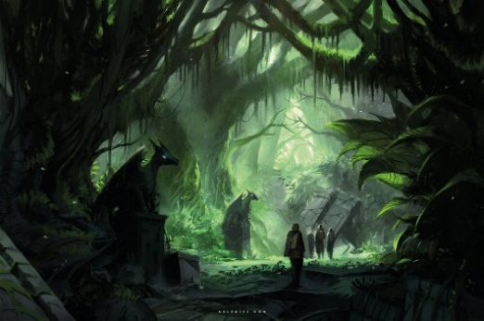

Figure 4 - Dark alien forest

The player must now escape from the island as quickly as possible before being captured and killed by the monster. They must run back to the boat before being captured.

The atmosphere will change throughout the escape. The sky and sun will get redder as time goes on to indicate the lack of time remaining. It will get duller and the players' view distance will decrease as a dark and thick fog will start invading the island.

If the player makes it back to the village, they will be able to see their boat docked. They must enter the boat and the victory cutscene will start to play. This cutscene is the player slowly rowing away from the island back to the mainland, they can see a large shadow of the monster covering the island and growling again. The next levels could consist of the player trying to find a way back to the real world.



Figure 5 - Twisted tree

If the player doesn’t make it back to the boat within the time constraint the defeat cutscene will play. This cutscene consists of the monster getting closer to the player and its dark energy-consuming them.

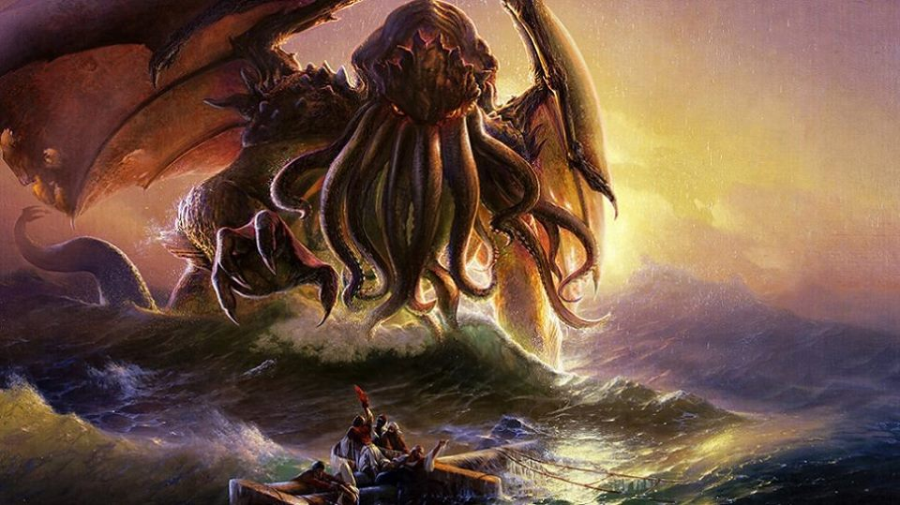

Figure 6 - Cthulhu

## Objective Summary

* Try to find missing persons by looking for a cabin.
* The player must find a way inside the cabin.
* While exploring the cabin they go down into a cave system, they must find a way out.
* They unlock the double jump ability.
* The player finds an old portal and the player steps through emerging in a different realm.
* The player unlocks shooting ability. This wakes up the monster.
* Try and exit the cave system from the other side.
* The player must complete platforming challenges (using the double jump and shooting) to escape the cave.
* The player must race to their boat under a time constraint. If they make it, they beat the level, if not they lose. A cutscene plays either way.

## Location

* Isolated Scottish island – Small village, with some unfriendly people
* Dull, overgrown forest – This forest holds the old cabin the player must break into
* The caves – Claustrophobic caves with seemingly no escape
* The other side – A strange realm almost mirroring the real world. Something seems off, the sky is darker and contains increased fog. Is home to the monster.

## Metrics

* Timing – The player has at least three and a maximum of four minutes from starting the level to escape.
* Visual Themes:
  + Old and poorly maintained buildings and docks
  + Overgrown forest
  + Claustrophobic caves
  + Strange alien world – The other side

## Level Atmosphere & Mood

It’s a dark and dull winter afternoon on the island, it is currently raining and there is some thunder and lightning, all paths and the soil is very muddy and slippery. The sky is full of very dark clouds indicating it could continue raining for a while. The trees are slowly dripping rainwater and the forest is very damp and muddy.

# High-Level Design Devices

## Player Activities & Actions

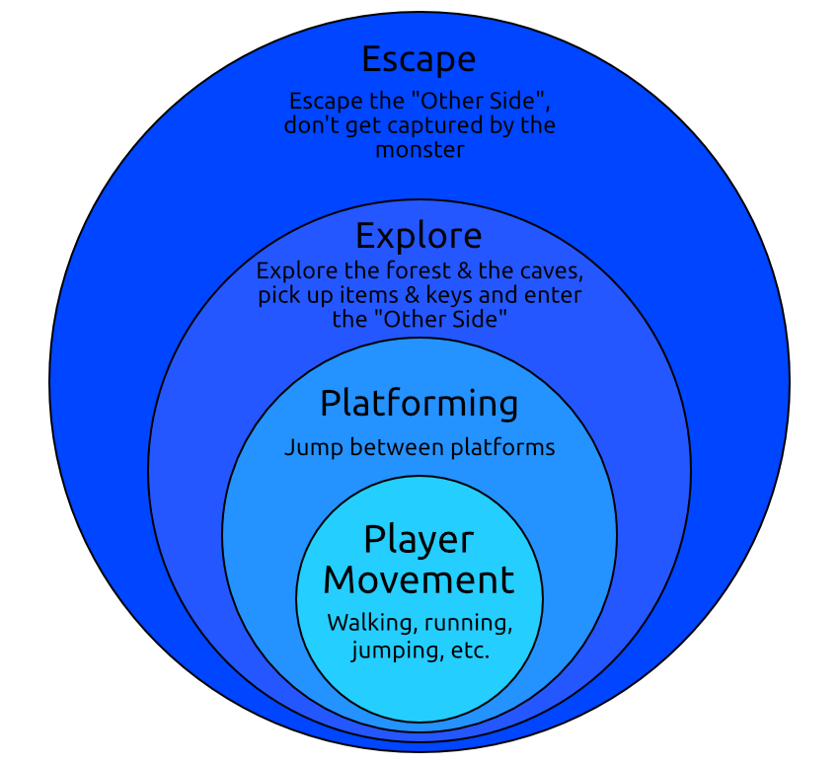

Figure 7 - Player Activities Onion Diagram

The player is capable of many different actions throughout the level. The onion diagram shows the different levels of importance each action represents and how each action depends on the previous. The actions in the outer layers are dependent on actions in the inner layers. For example, platforming isn’t possible without the player movement.

## Equation

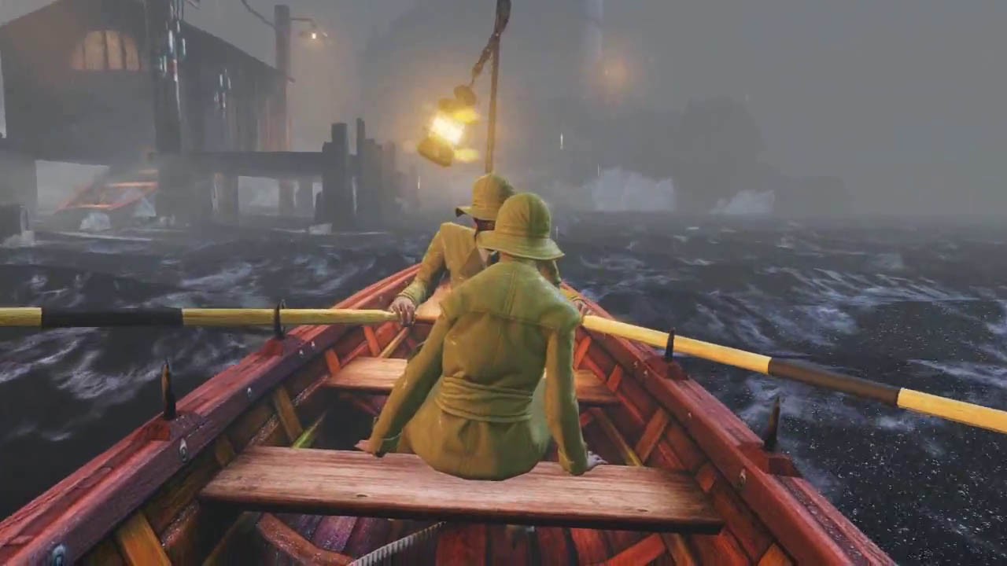

+

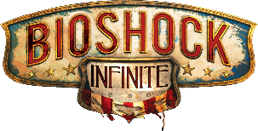

**Bioshock Infinite Opening**

Player arrives at an isolated island and gets transported to a different, unusual place.

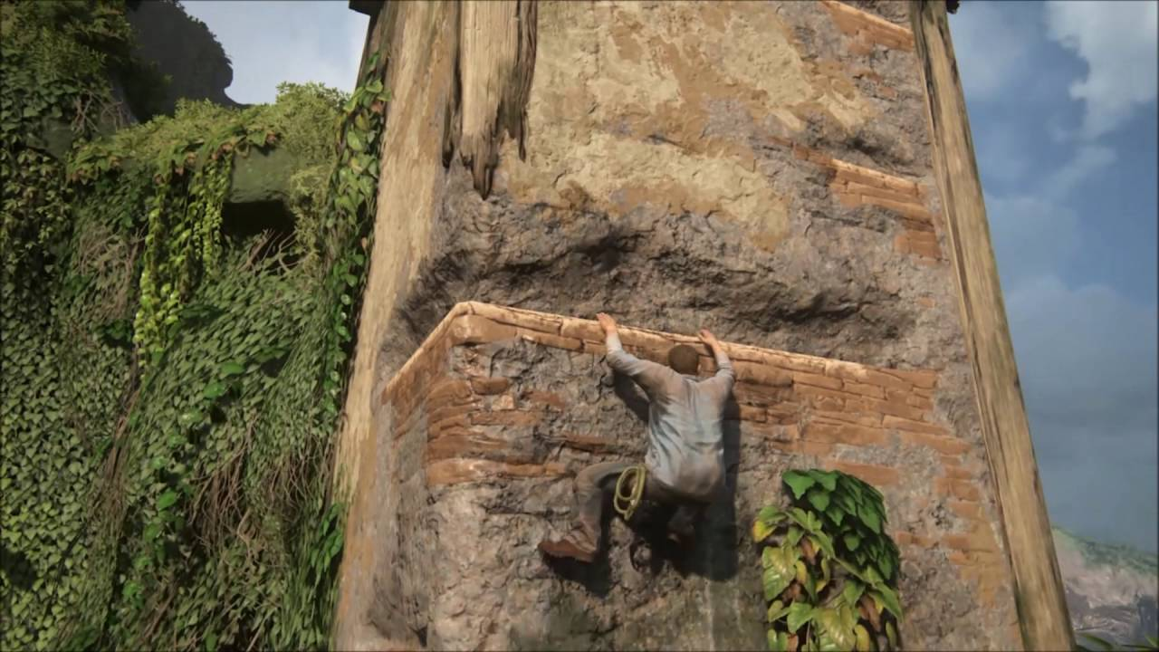

**Uncharted 4 Platforming**

Player must jump platforms and complete platforming / parkour challenges



Figure 8 - Equation

## Level Rules (Sieve)

Below are a set of rules the level must follow. If the level does not follow all these rules, it must be discarded. This is for the level to follow the same narrative and feel as if it belongs with the other levels included in the final game and with different regions of the level itself.

|  |  |
| --- | --- |
| * The player has at least three and a maximum of four minutes from starting the level to escape. * Escaping the other side must require the player to complete a challenge * The player must be able to use different items to break into the cabin. These items must be spread out enough to give the illusion that the player stumbled across an unintended item. | * The level must contain several physics objects the player can interact with. * Cutscenes must not be longer than 10 seconds at a time to keep the player engaged. * The player should have safe points around the level where they will not be in danger – Where the player could save & quit the game or where they will be reset to if they die. |

## 

# Level Design

## Level Flow Diagram

Below (figure 10) is a level flow diagram, this is a visual representation of the path the player will take through the level. At the end there is a split path, this the level outcomes. The victory outcome is when the player beats the level and escapes the island. The defeat outcome is when the player dies or gets captured by the monster.

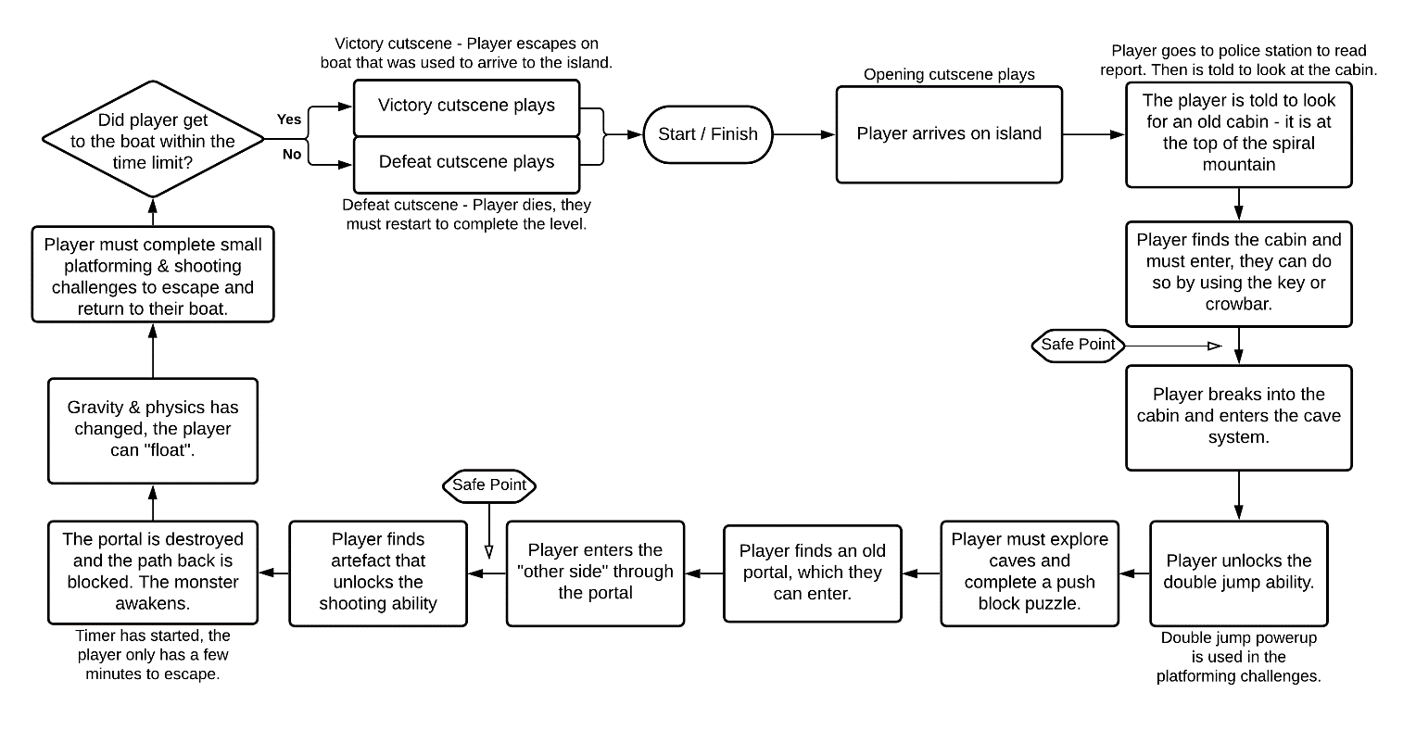

Figure 10 - Level Flow Diagram

## Level Bubble Diagram

Below are the bubble diagrams for the level, they represent the rough placement of areas on the map, you can see the spiral is the main landmark of the island, with a lighthouse and cabin in the center. On the right is the cave bubble diagram, as the caves exist inside the spiral mountain another image was needed to show the cave placement.

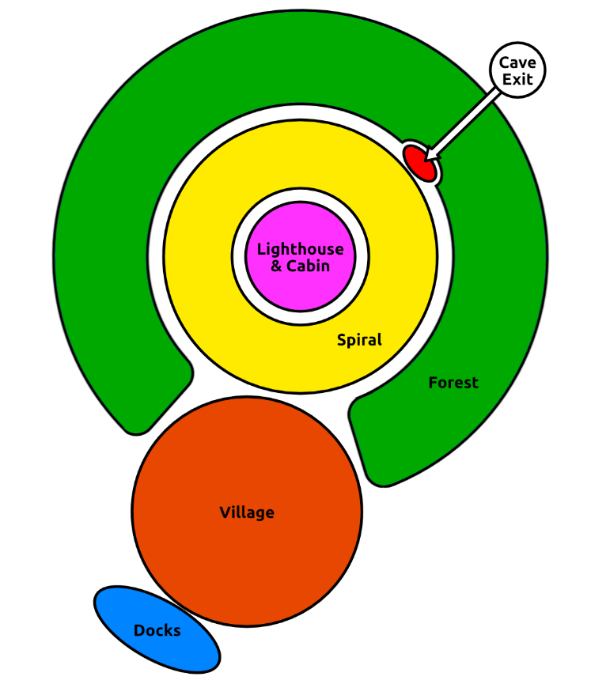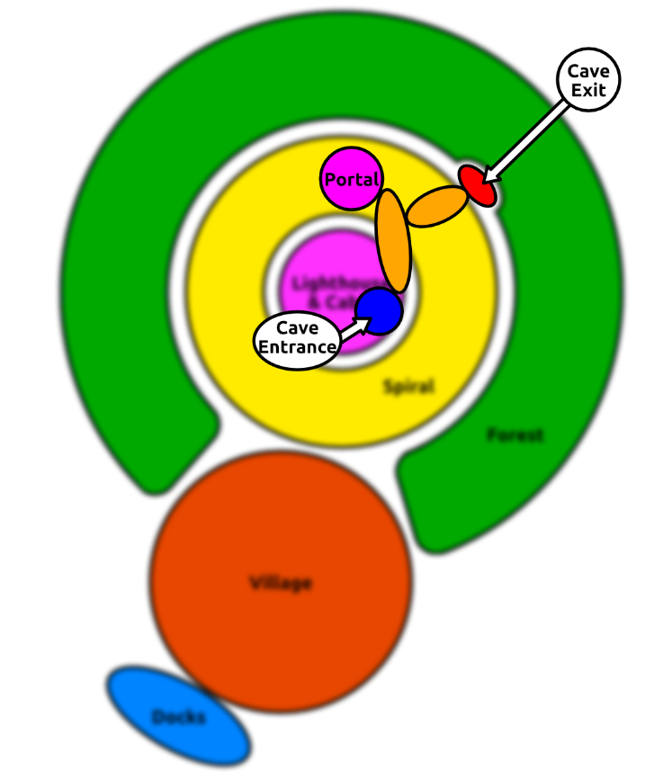

Figure 11 - Level Bubble Diagrams

## Detailed Level Bubble Diagram

The detailed level bubble diagram (Figure 12) includes the path the player can take (all the alternate paths are included). It also shows the puzzle and platforming challenge locations as well as where the player picks up items and unlocks new abilities.

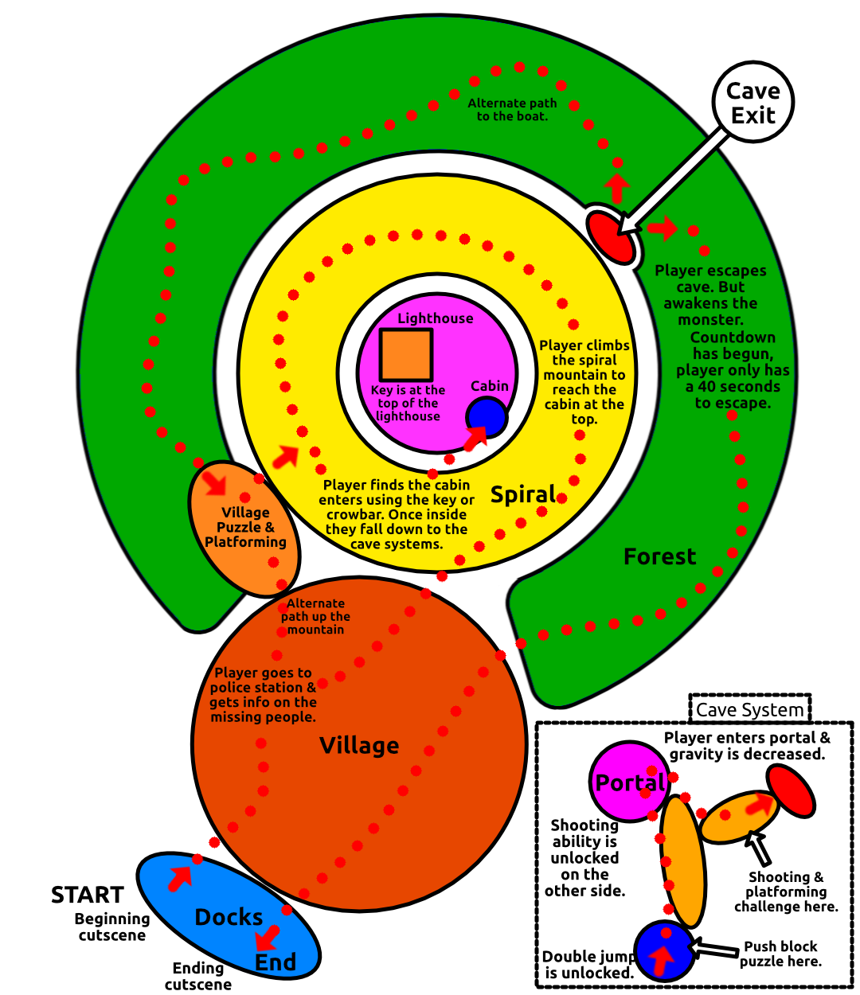

Figure 12 – Detailed Level Bubble Diagram

## Maps

### Island Map

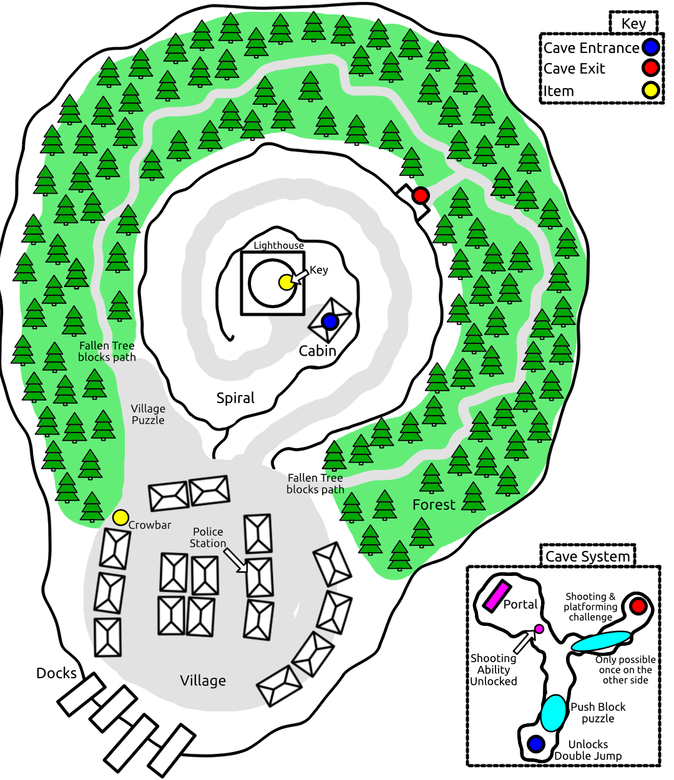

Figure 13 - Island Map

### Platforming & Puzzle Maps

The puzzle maps are detailed layouts of all the platforming and puzzles in the level. As they cannot be accurately shown on a map of the full island.

Below (Figure 14) is the Village puzzle, this is in the top left of the village and allows the player to get up the spiral quicker by completing a platforming challenge.

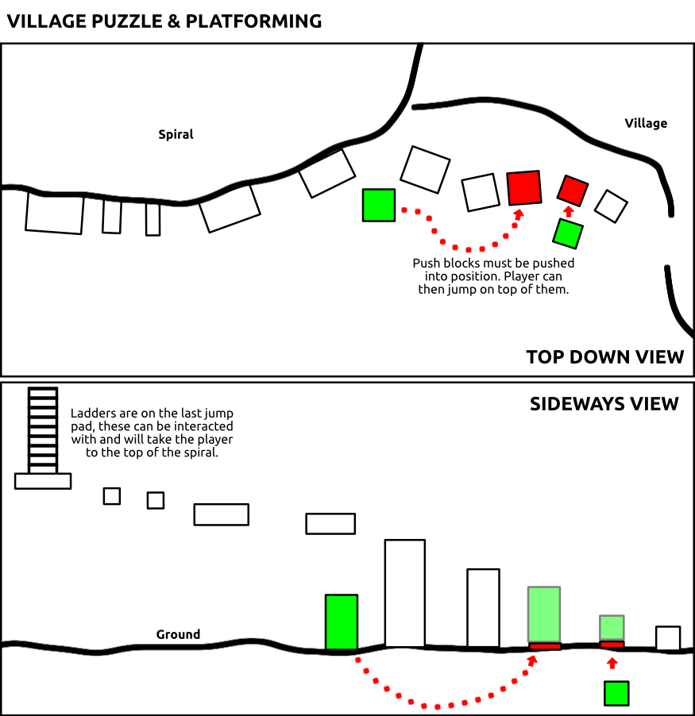

Figure 14 – Village Puzzle & Platforming Map

The next map (Figure 15) is for the lighthouse platforming, the player must climb up the inside of the lighthouse to collect the key at the top. The key is one of the items required for the player to enter the cabin.

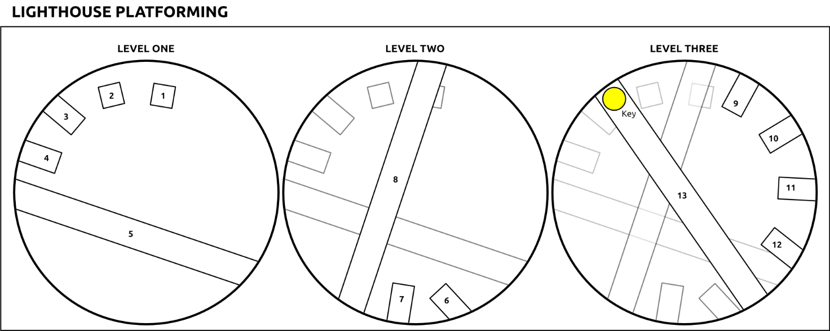

Figure 15 – Lighthouse Platforming Map

The next two maps are for the cave platforming. The first (Figure 16) is a map of the push block puzzle that must be completed by the player to open a door and progress through the level.

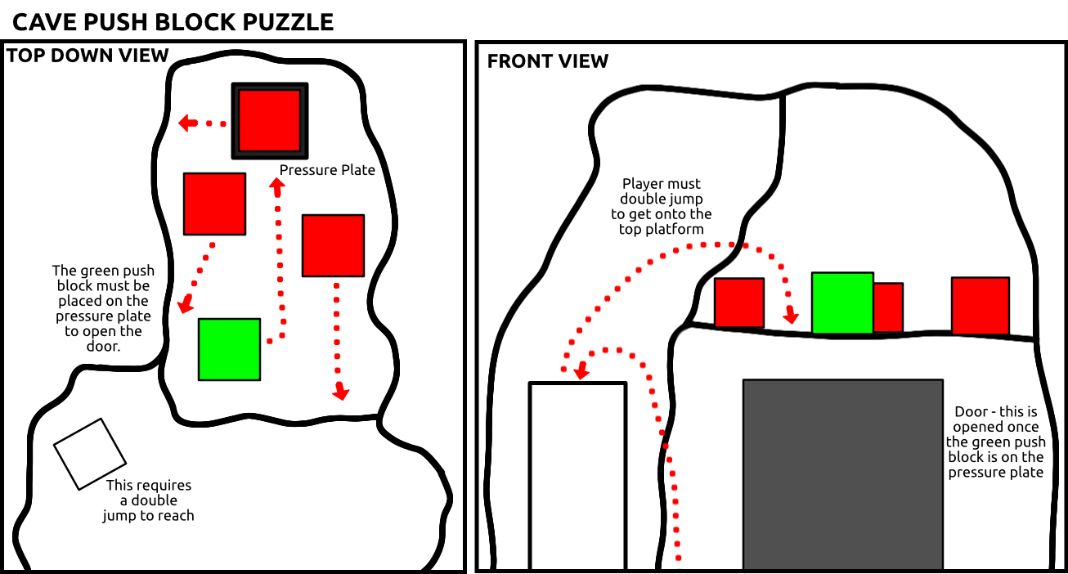

Figure 16 - Push Block Puzzle Map

Figure 17 shows the cave shooting ability platforming. This is when the player is leaving the cave, they must complete a platforming challenge as well as shoot 4 targets, once all targets have been shot the cave door will open and the player can escape to their boat.

## Elevations

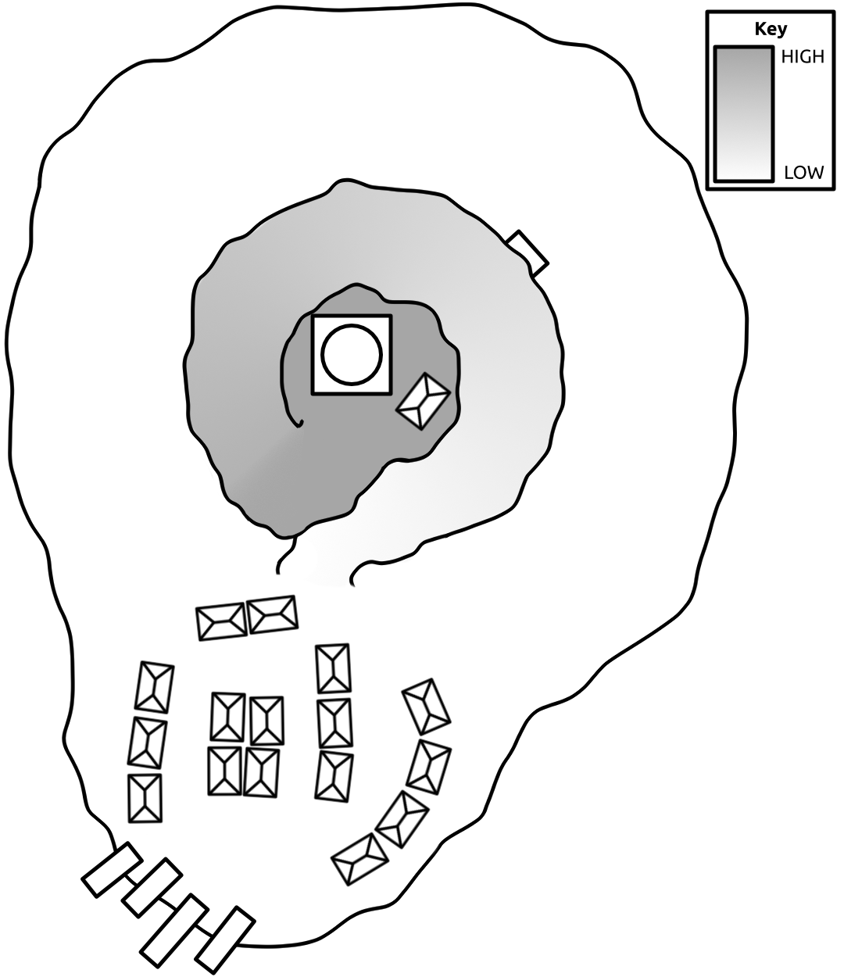

Figure 18 – Elevation Map

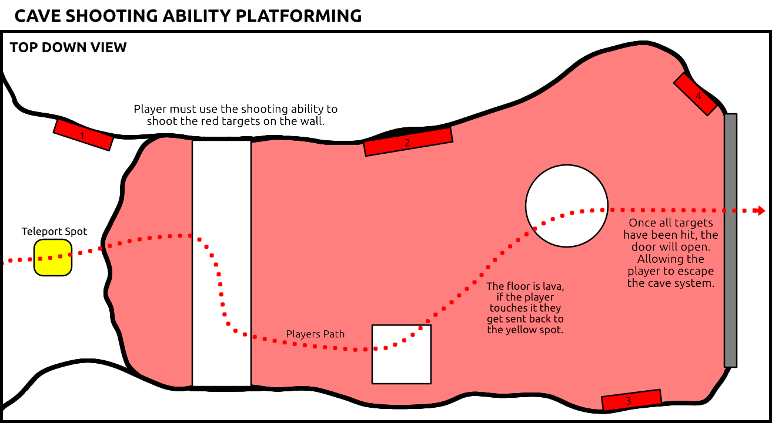

Figure 17 – Cave shooting ability platforming map

On the right (Figure 18) is the elevation map, this shows the different heights on the map.

# Game Design

## Lighting

There will be some atmospheric lighting throughout the level. The island is dull and set in the late evening, meaning the lighting will be very dim, it will contain one bright light which will be the lighthouse on top of the spiral hill in the centre of the island. A guiding light pattern will be used to guide the player throughout the level. This will be done by torchlight; small torches will be placed along the path leading the player to the abandoned cabin on top of the hill. Then through the cave and then back to the village once the player escapes the caves.

The portal will emit some light as well, this is another example of the guiding light level design pattern, as the player is guided to enter the portal.

Towards the end of the level (when the player is escaping the other side) the lighting will change and react to the time remaining. As time is running out the global lighting will get darker and redder and the player will not be able to see as far ahead as before, to accompany this, a fog will start appearing in the distance and will get heavier as time goes on. This will negatively affect the players' vision and make the level more difficult as the player progresses.

Throughout the level, lightning will strike around the island and give off a bright white light that illuminates the entire island. These are randomly timed and occur throughout the entire level.

## Physics

There will be a few physics objects throughout the level that the player can interact with.

First are the push blocks, these are cubes that the player can push around and place onto pressure plates. They use physics but are constrained to only be moved on the X and Y axis and to stop rotation. These push blocks are used for multiple puzzles and platforming in the level. In the village puzzle, the player moves them into position so they can jump on top of them to reach a higher ledge. In the cave push block puzzle, the player pushes these blocks onto a pressure plate to open a door and continue with the level.

Another physics object is the projectiles the player fires, they get created in front of the player and a velocity is added to them, so they shoot in front of the player. They are affected by gravity and physics so don’t travel in a straight line, instead they travel in an arc and will eventually touch the ground. These physics objects are shot at targets when the player is escaping the cave and allow the cave door to open.

## Particles

There will be multiple particle systems throughout the level.

The torches will have a simple fire effect that will use the Unreal fire textures, as well as a smoke effect that will slowly travel upwards while it fades away – this will also use Unreal textures. And finally, an embers effect to add small sparks and material emanating from the torch.

The dark energy particle system will be created using the new Unreal Niagara particle system, this allows for more advanced and 3D particles. In this case, the dark energy particles will consist of small black metal cubes that grow from nothing and slowly shrink to nothing. The cubes float around and are affected by multiple physics systems and forces, such as wind, drag, vortex, gravity, and a point attraction force. The particles will also emit a dark red light.

The monster is only visible during the cinematics but will use the dark energy particles but with higher physics and forces to make the cubes move around more rapidly. As the cubes are attracted to the centre of the particle system it gives the appearance that the monster can control the dark energy and it is an extension of the monster.

The portal will have its own particle effect as well, but it will be closely linked to the dark energy, there will be some red smoke emanating from the portal and then small dark energy particles flying in and out of the portal.

On the other side, there will be a red fog particle effect that covers the ground in the caves, this is to show a difference between the normal world and the other side. The fog will use the smoke textures included with Unreal but tinted red, to go along with this fog, there will be a few dark energy particle effects too, these will slowly float around and be inside the entire cave.

## Logic

### Interaction

The player can interact with different objects around the level, they even have an inventory to hold basic items. However, they cannot be used traditionally. Interaction with objects will use a sphere trace from the camera, this way anything the player looks at they can have the option to interact with. This will be done through an interface that blueprints can implement, this way when the sphere trace goes over an object it looks for an actor that implements this interface and each actor can implement something different depending on what that actor is without having to add it to the sphere trace.

### Torches

The torches will use logic to randomise the lights intensity and its range, this is a very simple blueprint that, each frame, will choose a random number for its intensity and range. This gives a subtle flickering effect just like fire in the real world.

### Push Blocks

Push blocks will use logic to be pushed around and when to toggle physics simulation. Around the box, there is an X and Y overlap collider that sticks out from the actual block itself. If the player walks into the overlap colliders the blocks will start simulating physics and the player can push them around, once they leave the overlap collider the physics simulation stops, and they cannot move. It will be done this way rather than allow physics simulation all the time because it will allow the player to jump on top of the blocks without them moving or sliding around.

### The Other Side Portal

The portal will use logic to teleport the player in front of the portal and turn them around. This is to give the illusion that the player entered the portal and has now emerged onto the other side. The logic will also disable the portal stopping the player from being able to return to the overworld. As the player is now in the other side, new assets and actors need to be added or enabled. To do this, the portal blueprint will search for all objects labelled “OtherSide” and set them to visible, by default they will not be visible, so the player will not be able to see or interact with them until they have entered the portal. There will also be a tag called “Overworld” (these objects are visible by default) and when entering the portal their visibility will be set to false, this is to allow for certain actors to only be visible during the overworld, e.g. police officers, trees blocking the path.

### Objective System

The objective system is used to help guide the player on what they need to achieve next, but there will be specific blueprints around the level that advances the objective. The first way of doing this is through an overlap collider, if the player walks through this collider then the objective will advance, this will be used for reaching the top of the spiral and discovering the cabin when falling down to the cave system, when leaving the cave system and when reaching the boat at the end of the level. The next way is through the interaction system, for example, the objective will need to be updated once the player has talked to the police officers or after reading the missing person’s report.

### First Ability: Double Jump

The level includes two unlockable abilities. The first ability is the double jump, this will require changes to the character controller blueprint. This can be done by adding an upwards force to the player when they are airborne but must not allow the force to be added more than once – this is to stop infinite jumping/jumping in the air. This is locked when starting the level but gets unlocked when entering the cave system.

### Second Ability: Shooting Dark Energy

The player has a projectile that they can fire once it is unlocked in the caves. This projectile is spawned a few units in front of the player and is given a positive velocity, so they shoot forwards away from the player. If the projectile hits a collider it will destroy itself, if that collider happens to be a target then it will activate the target. There are 4 targets in the level, these targets are linked together so all must be active for the cave door to open. They also change colour when active. They start red and once they have been activated, they turn green. This is done through a dynamic material instance that allows for a material to be updated throughout the level without having to reapply it to the mesh.

### Weather System

The weather system will consist of a directional light that can be turned on and off quickly to create lightning flashes and a post-process material that creates rain. The directional light will be randomly turned on and off and have its intensity randomly set, this way it looks like natural lightning occurring over the island. The post-process material will need to be set active and inactive throughout the level depending on if the player is inside or under an overhang/cover. This will be done through an overlap collider, if the player walks into this collider the post process rain material will be disabled, and once they leave it will be enabled again.

## User Interface (UI)

### Heads Up Display (HUD)

The level will include a minimal HUD only showing information the player will need throughout the level. Figure 19 is a diagram of the HUD.

In the top-left will be a current objective text telling the player what they need to do next. It will update automatically at different points throughout the level depending on what the player needs to do next. Below the current objective is the time remaining widget, this will only appear when the player is under a time constraint at the end and must race back to the boat. The widget will show the time remaining before the end of the level and the player loses.

The bottom-right will contain the inventory bar, this is where any items the player picks up will be displayed, there is a maximum of 3 items that the player can carry. The player doesn’t have to worry about selecting any items in the inventory, if something in the level requires an item, it just needs to be in the inventory.

The HUD also includes two popup text widgets, the interaction popup text will only be visible when the player is looking at an object that they can interact with, and the text will get changed to whatever the interaction is. The ability unlocked popup text will show whenever the player unlocks an ability, and how they can use it. For example, when unlocking the jump ability, it could read: “Jump ability unlocked! Press space while in the air to jump again!”.

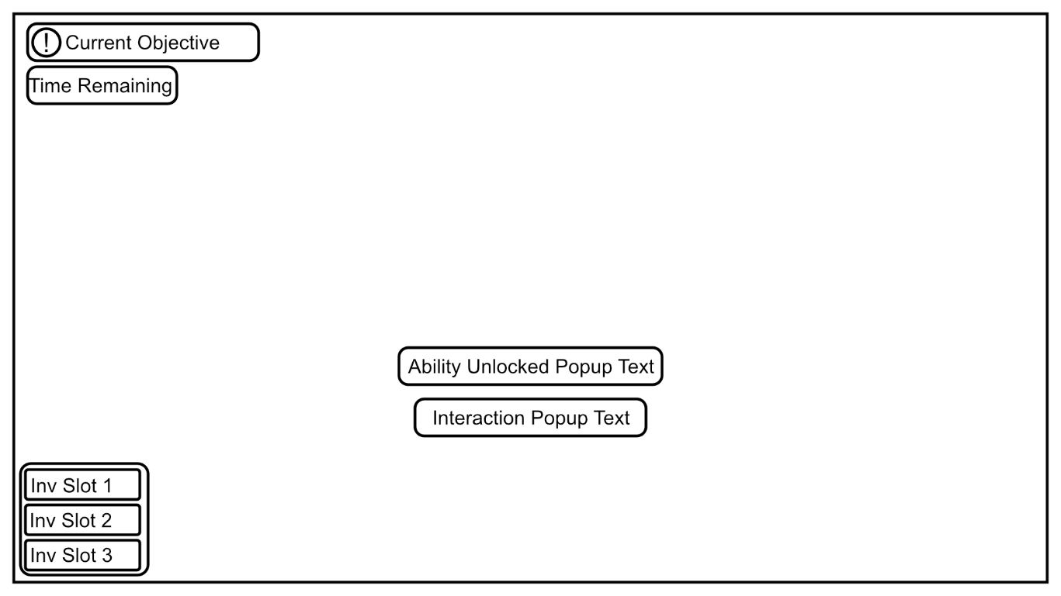

Figure 17 - In-Game HUD Layout

## Audio & Sounds Effects

### Weather System

The weather system is accompanied by some sound effects, in the background, there is a looping rain/storm sound. Every time there is a lightning strike a few seconds after the light effects a lightning sound effect will play, there are multiple audio files and one is randomly chosen, this is to stop the same sound from being repeated a lot.

### Stone Door Opening

When a stone door opens (Cave Push Block Puzzle and the Cave Target Shooting Platforming) a sound effect will be played to indicate to the player that the door has opened, and they can enter.

### Entering the Portal

When the player enters the portal a sound effect will play.

### Monster Sound Effect

During the final cinematics, the monster will create a screech sound effect.

## Cinematics

There will be multiple cinematics in the level, there is an opening cinematic and two ending cinematics (a win and lose cinematic).

## Opening Cinematic

The camera starts off looking at the lighthouse with its light spinning around. The camera pans down to view the village and zooms in to focus on the police station. From here the camera follows the path around the village back to the docks where the player is standing. The player gains control here. The opening cinematic is used to pinpoint areas of interest for the player so they would want to go explore. For example, one of the first objectives is to go to the police station and talk to the police officers, and another example would be that the key to the cabin is found in the lighthouse and the player will need to go explore the lighthouse to find it.

## Ending Cinematic

### Win Cinematic

The win cinematic is a shot of the player in the boat slowly departing the island, the camera then moves back into the island and focuses on the monster. The monster plays a screech sound effect and the level ends. This cinematic sets up the monster as a boss on the island and gives the player an idea of what they were running from, in later levels the player could return to the island and defeat the monster.

### Lose Cinematic

The lose cinematic consists of a camera in front of the player's character. The player is consumed by the monster as its dark energy takes over the player and the player's character plays a death animation.

## Entities

### Villager

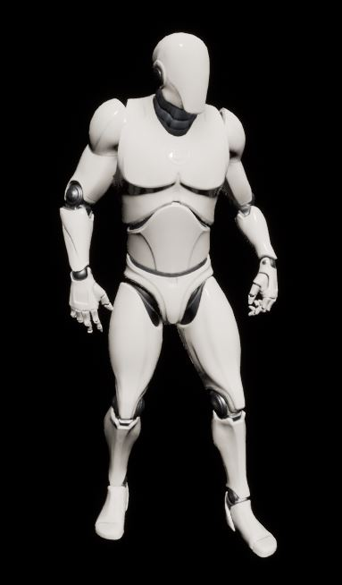

Figure 18 – Villager Model

**Motives / Objectives**

* Add life to the level
* To push the player to explore the village and find the cabin on the spiral mountain
* Help direct the player around the village and give the player hints

**Uses Within Level**

* Direct player around the island
* Help explain certain areas within the level (Village platforming area, and the crowbar)
* Used in the police station – player can talk to them and progress the level

### Monster

**Motives / Objectives**

* Kill the player once they enter the other side

**Uses Within Level**

* The player runs away from the monster during the last objective
* The monster is used in the ending cinematic

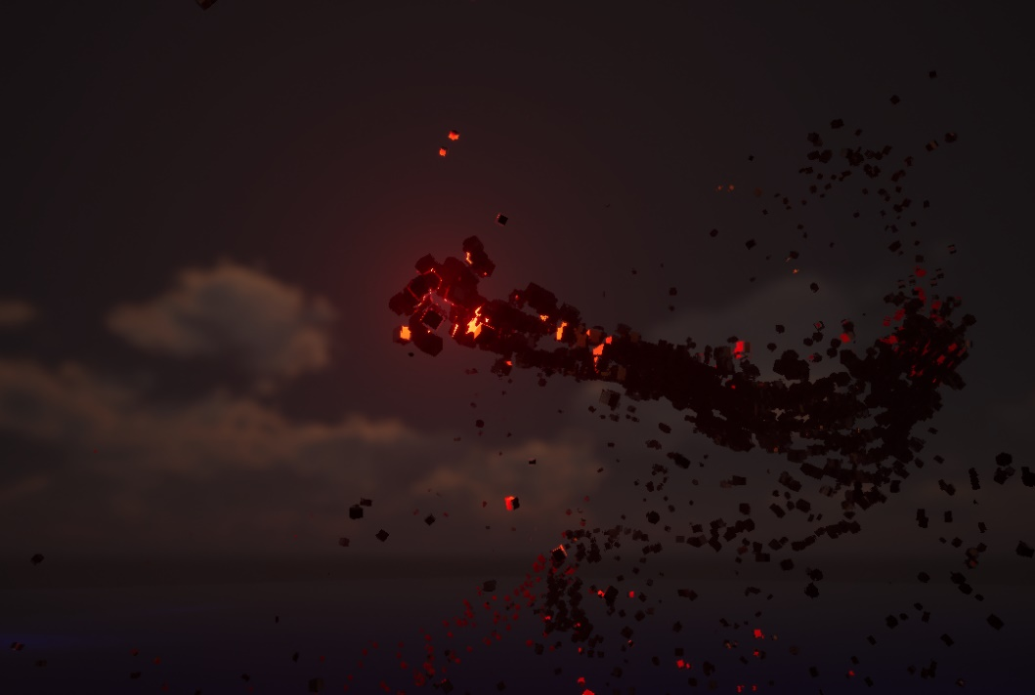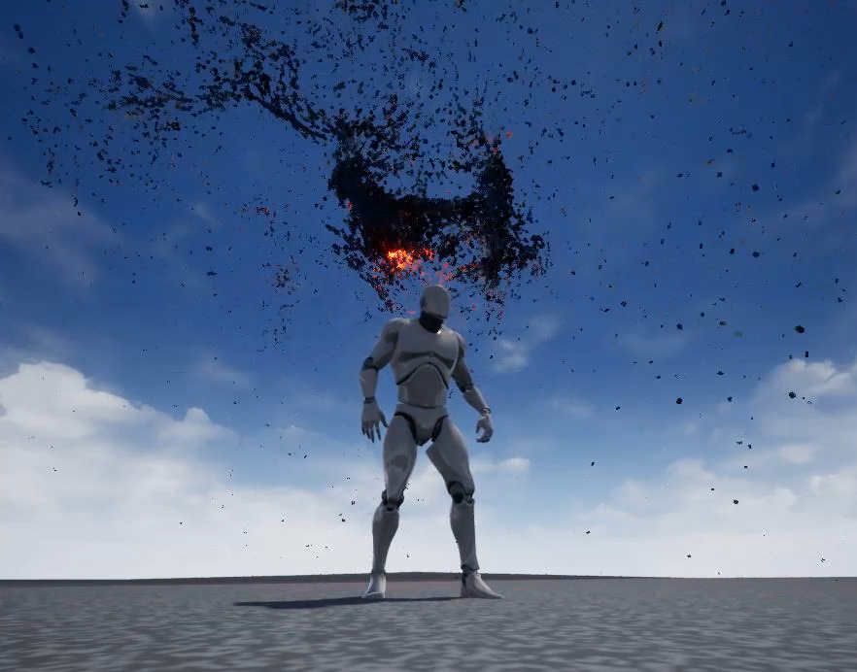

Figure 19 – Monster

### Key

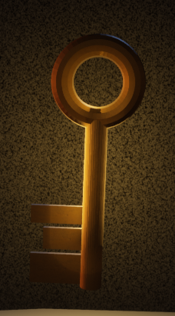

Figure 20 – Key Item

**Motives / Objectives**

* Inventory item
* Unlocks cabin door
* Is found at the top of the lighthouse, the player must complete a platforming challenge to pick up the key

**Uses Within Level**

* Unlocks cabin door

### Crowbar

**Motives / Objectives**

* Inventory Item

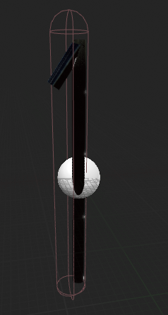

Figure 21 - Crowbar

* Unlocks cabin door
* The crowbar is found in the village next to a villager

**Uses Within Level**

* Unlocks cabin door